Software Installation Steps

Contents

Installation Instructions Before You run the code. 3

Install Python 3 with the Official Installer 3

Installing pip package 6

Installing Anaconda 7

Installing Jupyter Notebook 9

To launch jupyter notebook 10

Installing additional packages/Libraries 10

SQLite Database 11

# Installation Instructions Before You run the code.

## Install Python 3 with the Official Installer

Downloading the latest Python version from the official Python website (python.org) is the most common (and recommended) method for installing Python on a Mac. Let’s try it out.

First, download an installer package from the Python website. To do that, visit https://www.python.org/downloads/ on your Mac; it detects your operating system automatically and shows a big button for downloading the latest version of Python installer on your Mac. If it doesn’t, click the macOS link and choose the latest Python release.

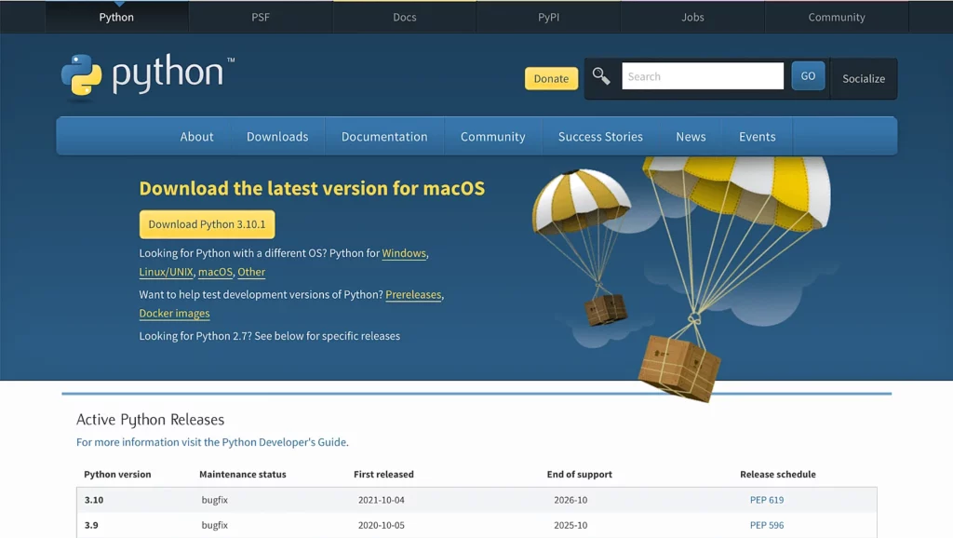

2. Once the download is complete, double-click the package to start installing Python. The installer will walk you through a wizard to complete the installation, and in most cases, the default settings work well, so install it like the other applications on macOS. You may also have to enter your Mac password to let it know that you agree with installing Python.

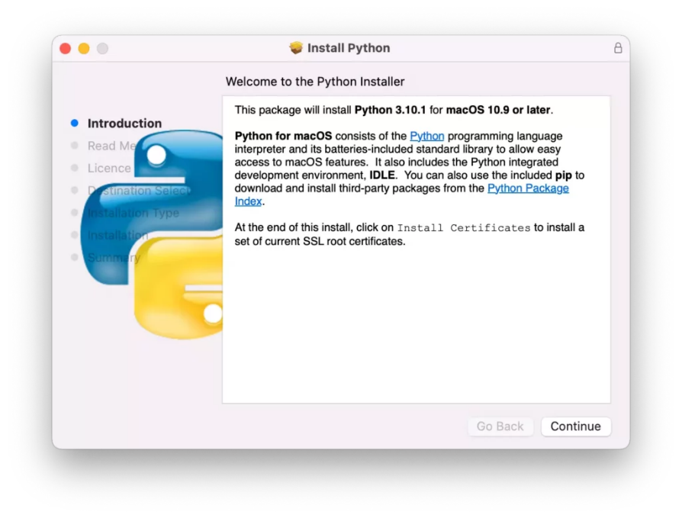

3. When the installation completes, it will open up the Python folder.

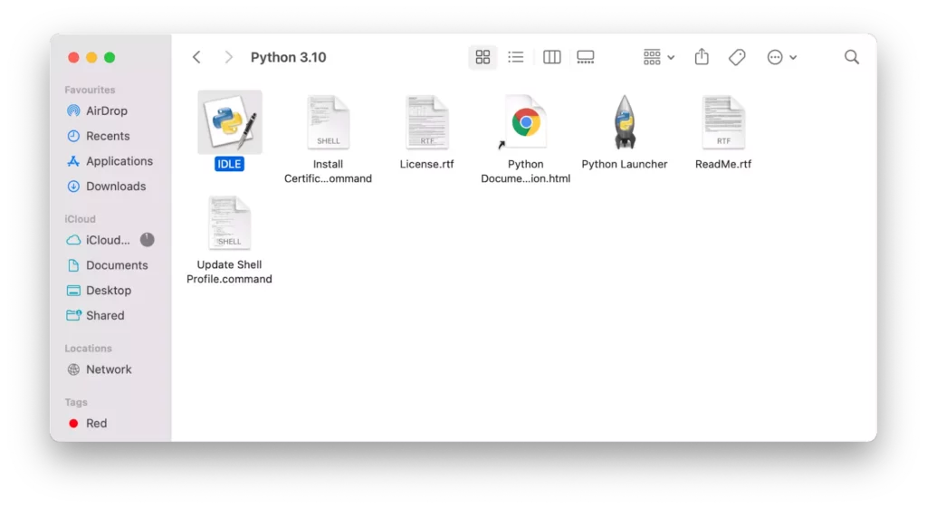

4. Let’s verify that the latest version of Python and IDLE installed correctly. To do that, double-click IDLE, which is the integrated development environment shipped with Python. If everything works correctly, IDLE shows the Python shell as follows:

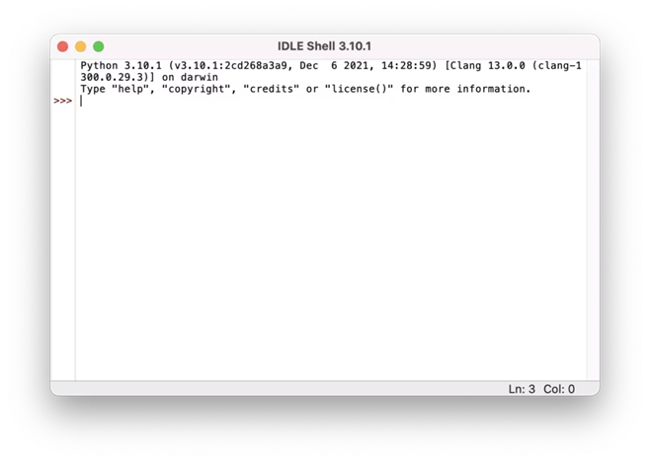

5. Let’s write a simple Python code and run it in IDLE. Type the following statement, and hit the return key.

print(“Hello, World!”)

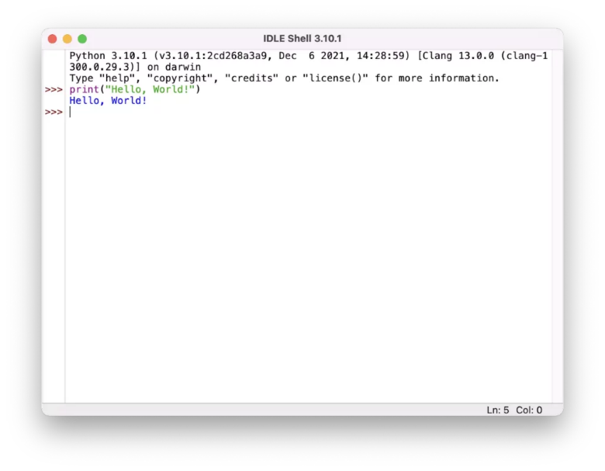

## Installing pip package

There are several methods to install additional Python packages:

Packages can be installed via the standard Python distutils mode (python setup.py install).

Many packages can also be installed via the setuptools extension or pip wrapper, see https://pip.pypa.io/.

OR simply Open terminal and type below commands one by one.

curl https://bootstrap.pypa.io/get-pip.py -o get-pip.py

python3 get-pip.py

validate whether PIP got installed.

pip help

pip3 –version

pip –version

## Installing Anaconda

(reference: https://problemsolvingwithpython.com/01-Orientation/01.04-Installing-Anaconda-on-MacOS/)

1. Visit the Anaconda downloads pageGo to the following link:

Anaconda.com/downloads

2. Select MacOS and download the .pkg installer

In the operating systems box, select [MacOS]. Then download the most recent Python 3 distribution (at the time of this writing the most recent version is Python 3.6) graphical installer by clicking the Download link. Python 2.7 is legacy Python. For problem solvers, select the most recent Python 3 version.

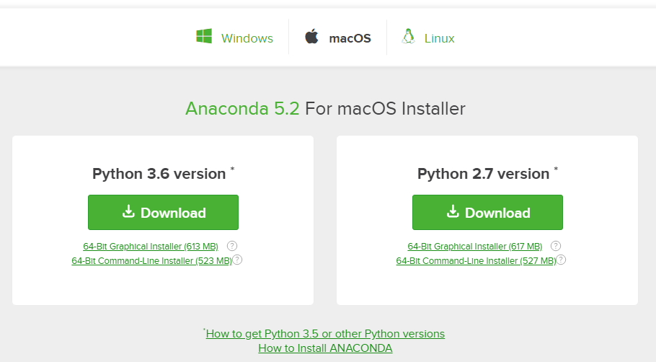

You may be prompted to enter your email. You can still download Anaconda if you click [No Thanks] or [x] and don't enter your Work Email address.

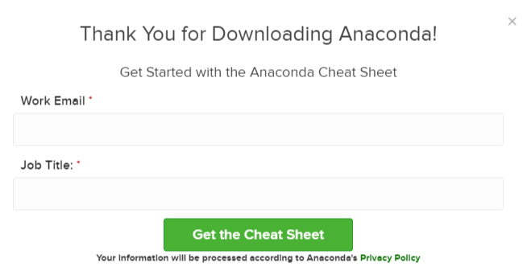

3. Open the .pkg installer

Navigate to the Downloads folder and double-click the .pkg installer file you just downloaded. It may be helpful to order the contents of the Downloads folder by date to find the .pkg file.

4. Follow the installation instructions

Follow the installation instructions. It is advised that you install Anaconda for the current user and that Anaconda is added to your PATH.

5. Source your .bash-rc file

Once Anaconda is installed, you need to load the changes to your PATH environment variable in the current terminal session.

Open the MacOS Terminal and type:

$ cd ~

$ source .bashrc

6. Open a terminal and type python and run some code.

Open the MacOS Terminal and type:

$ python

You should see something like

Python 3.6.3 | Anaconda Inc. |

At the Python REPL (the Python >>> prompt) try:

>>> import this

If you see the Zen of Python, the installation was successful. Exit out of the Python REPL using the command exit(). Make sure to include the double parenthesis () after the exit command.

>>> exit()

## Installing Jupyter Notebook

Installing Juypter

The simplest way to install Jupyter notebooks is to download and install the Anaconda distribution of Python. The Anaconda distribution of Python comes with Jupyter notebook included and no further installation steps are necessary.

Below are additional methods to install Jupyter notebooks if you are not using the Anaconda distribution of Python.

Installing Jupyter on Windows using the Anaconda Prompt

To install Jupyter on Windows, open the Anaconda Prompt and type:

> conda install jupyter

Type y for yes when prompted. Once Jupyter is installed, type the command below into the Anaconda Prompt to open the Jupyter notebook file browser and start using Jupyter notebooks.

> jupyter notebook

Installing Jupyter on MacOS

To install Jupyter on MacOS, open the MacOS terminal and type:

$ conda install jupyter

Type y for yes when prompted.

If conda is not installed, the Anaconda distribution of Python can be installed, which will install conda for use in the MacOS terminal.

Problems can crop up on MacOS when using the MacOS provided system version of Python. Python packages may not install on the system version of Python properly. Moreover, packages which do install on the system version of Python may not run correctly. It is therefore recommended that MacOS users install the Anaconda distribution of Python or use homebrew to install a separate non-system version of Python.

To install a non-system version of Python with homebrew, key the following into the MacOS terminal. See the homebrew documentation at https://brew.sh.

$ brew install Python

After homebrew installs a non-system version of Python, pip can be used to install Jupyter.

$ pip install jupyter

## To launch jupyter notebook

open terminal or anaconda prompt and type:

$ jupyter notebook

Follow guidelines on for further instruction on how to use Jupyter notebook

https://problemsolvingwithpython.com/02-Jupyter-Notebooks/02.04-Opening-a-Jupyter-Notebook/

## Installing additional packages/Libraries

Open terminal and type below command to install additional libraries/

*pip3 install pandas*

*pip3 install matplotlib*

*pip3 install numpy*

*pip3 install seaborn*

*pip3 install plotly*

*pip3 install dash*

*pip3 install folium*

## SQLite Database

If you input/source data is stored in sqlite database example: [database.sqlite](https://github.com/Adikharche19/ipl_da_using_sql/blob/main/data/database.sqlite) and if one wants to see the data before loading it into jupyter notebook then follow below instructions.

1. Please go to <https://sqliteonline.com/>
2. Click on File and then click on Open DB which will open browser on your PC which will allow you to select your source .sqllite database file.

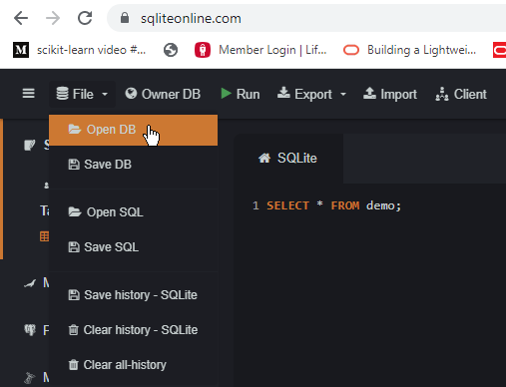

1. Once you click on SQLlite file then you will see all the tables in left side. You can query those table in right window (select * from table) and click on Run button on the top to execute it.
2. You can build your query here and analyze your data in this UI before you embed your SQL query in jupyter notebook.